2024-2025 Beef Grant for FCS Foods Classes

The Iowa Beef Industry Council (IBIC) will provide funds for the purchase of beef for each high school or middle school foods class for the 2024-2025 school year. The total per school is not to exceed $750.00 per year. The funds are available for Iowa teachers and classrooms only.

These funds provide financial support for the purchase of beef for use in classroom lessons about lean beef selection, storage, preparation and nutrition. The funds are to be used in a classroom activity.

To receive these funds:

To receive funds – download forms at www.iabeef.org: Family and Consumer Science Teachers
- Fill out Form 1 – Application for Beef Grant which includes description of the Foods classes and how the funds will be used in classroom lessons/activities.
- Return to IBIC (address below). IBIC will contact you with approval via email.
- Purchase beef (NO receipts required)
- Submit the following documents:
____ Form 2 – Reimbursement Request /Evaluation/ Success Story/Pictures- that we can put on our website for other teachers to use

No funds will be reimbursed after June 30, 2025.

Educational materials for the classroom can be found on our website, go to www.iabeef.org and click on Family and Consumer Science Teachers.

Iowa Beef Industry Council
PO Box 451
Ames, IA 50010
Phone: 515-296-2305 Fax: 515-296-4873
www.iabeef.org
beef@iabeef.org

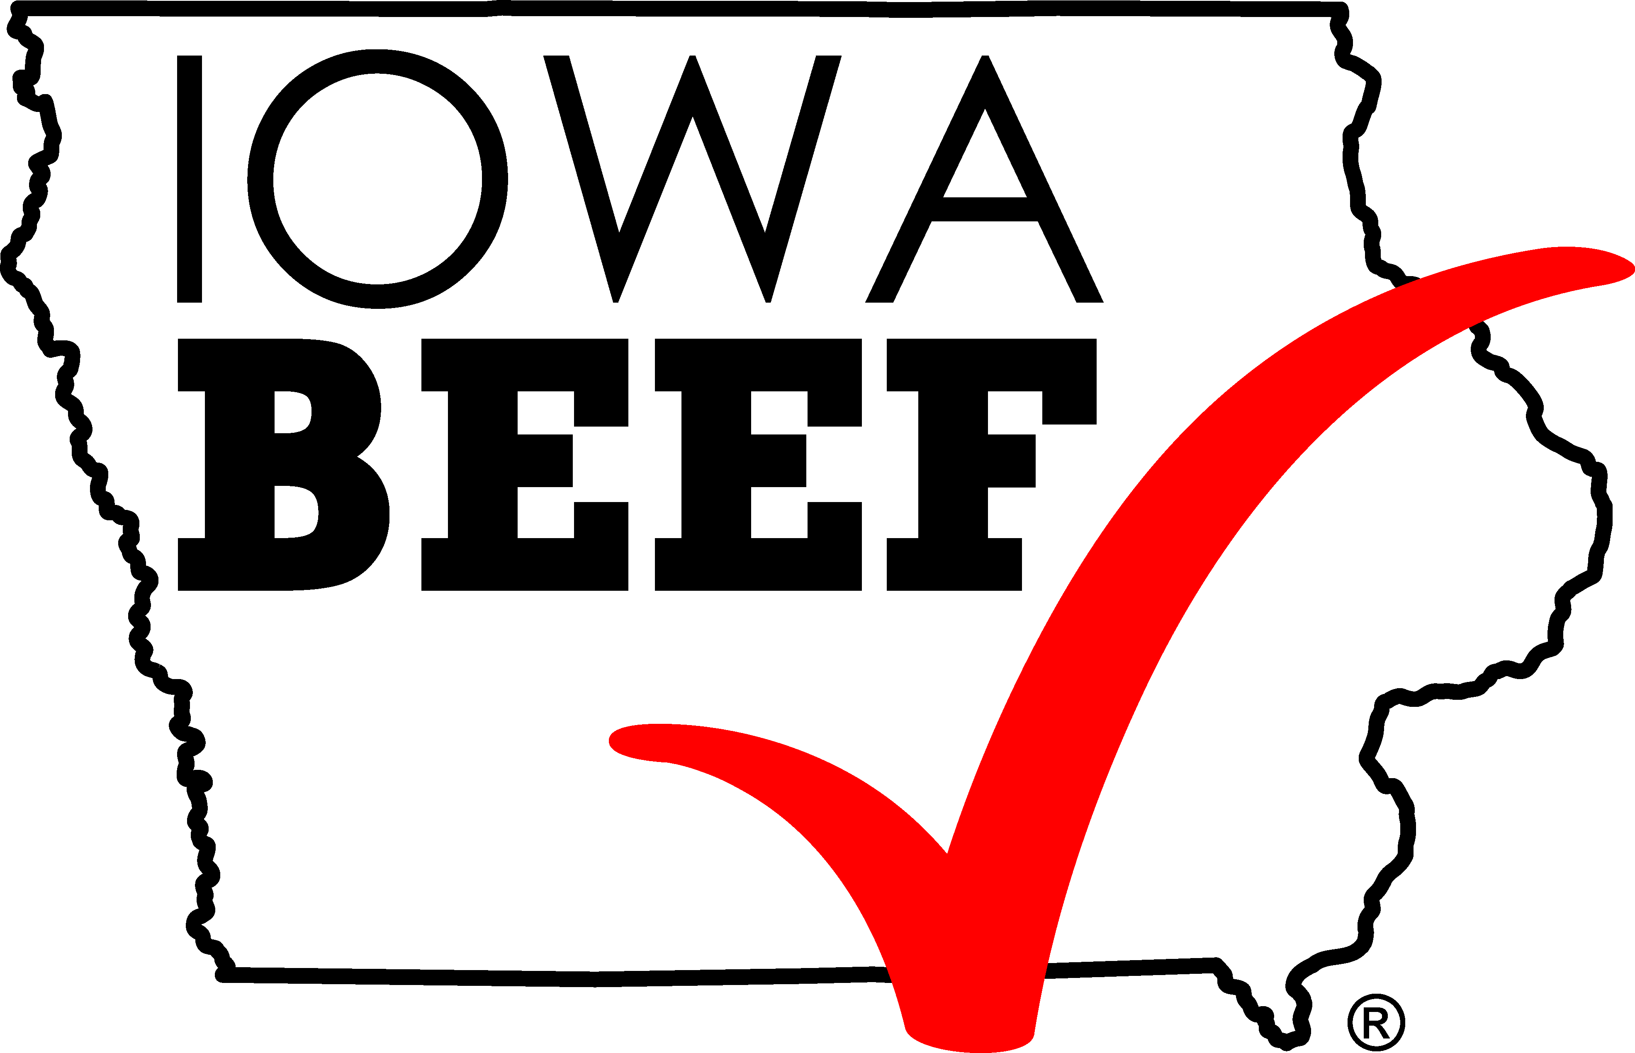

Application for Beef Grant Form 1

2024-25 Beef Grant for FCS Foods Classes

Please fill out one form per school (Foods I, Foods II -multiple classes may be indicated).
Date __________________

Name of FCS Educator

Email address - required

School Name

Address

City and Zip

Phone contact

Name of Class
Grade Level

Briefly describe how you plan to use beef as a teaching tool. You may attach lesson plans if it is easier than completing this section.

Iowa Beef Industry Council Approval _____________________________ Date ___________________
Return to: Iowa Beef Industry Council, PO Box 451, Ames, IA 50010, or email: beef@iabeef.org.

Reimbursement Request/Evaluation/Success Story Form 2
2024-25 Beef Grant for FCS Foods Classes

Please fill out and mail / fax / email PRIOR to June 30, 2025
Name/FCS Educator:
School:
Address:
City: | State: Zip:
# of students helped by grant: | School phone:
# of classes
Total $$ to be reimbursed | Email:
Check written to (include address)

List of ways in which beef was prepared and your Success Story (that we can share on our website)

- Both forms (approval, reimbursement/ evaluation) must be received by IBIC before receiving funds.
- Success story or ways you used beef to inspire your students that we can share on our website
Return to: Iowa Beef Industry Council, PO Box 451, Ames, IA 50010, or email: beef@iabeef.org,
or FAX – 515-296-4873
If you have additional comments or suggestions, please attach and send in.

